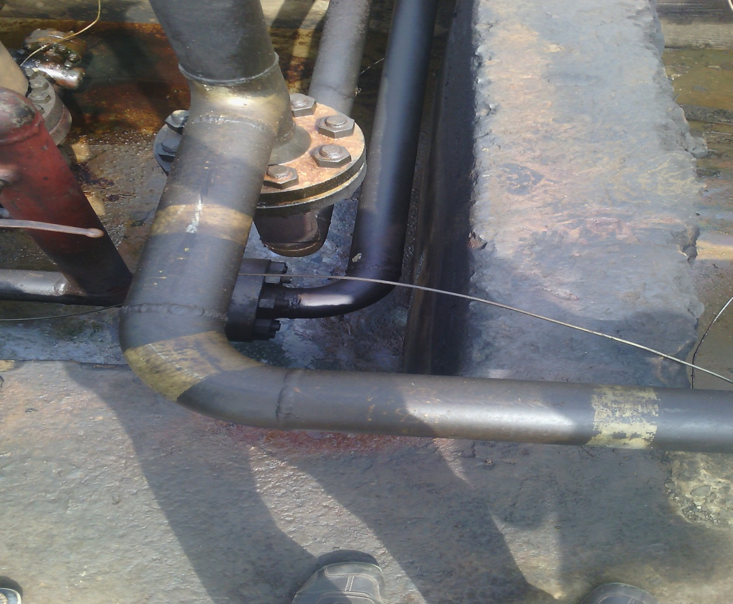

Spill point @ 5 0’clock position

